UNIVERSITY OF SKILLS TRAINING AND ENTREPRENEURIAL DEVELOPMENT (USTED)
ICT 244 — SYSTEMS ANALYSIS & DESIGN
Group Project Report
Scenario:
Design of a Campus Event Registration System (CERS)

Field | Detail
Course Title | Systems Analysis & Design
Course Code | ICT 244
Lecturer & TAs | Franco Osei-Wusu, Wendy Osei-Frimpomaa, Kwadwo Agyei Baffour
Group Number | Group ___
Group Members (Index No. & Name) | 1. ______________________ (Index No: ______) 2. ______________________ (Index No: ______) 3. ______________________ (Index No: ______) 4. ______________________ (Index No: ______) 5. ______________________ (Index No: ______)
Scenario Title | Campus Event Registration System (CERS)
Date | 9th August, 2026

Table of Contents
1. Background of the Selected Scenario
2. Problem Statement
3. Project Objective
4. Stakeholder and User Analysis
5. Project Initiation and Feasibility Justification
6. Requirement Gathering Approach and Summarized Requirements
7. Task 1: Use Case Analysis
8. Task 2: Data Flow Diagram Analysis
9. Comparison: Use Case Analysis vs DFD Analysis
10. Conclusion and Lessons Learned
11. Appendices

1. Background of the Selected Scenario
The University of Skills Training and Entrepreneurial Development (USTED) hosts a wide range of student and departmental events throughout the academic year, including departmental symposia, career fairs, guest lectures, cultural festivals, sports days, and entrepreneurship pitch competitions. These events are organized by student groups, departments, and the Students' Representative Council (SRC), and typically require students to register in advance so that organizers can plan seating, catering, and materials.
Currently, event registration at USTED is handled manually or through disconnected tools. Organizers announce events through posters, WhatsApp groups, or verbal announcements, and students indicate interest by filling paper forms, sending direct messages, or being added to spreadsheets. Venue booking is arranged separately by contacting the Estates/Facilities office, and there is no central system that connects event announcements, student registration, venue allocation, and payment where an event requires a fee (such as a workshop or dinner event).
This project proposes a Campus Event Registration System (CERS) — a web-based information system that centralizes event creation, student registration, venue allocation, payment processing (for paid events), and attendance reporting for the university.

2. Problem Statement
The existing (As-Is) manual process for organizing and registering for campus events suffers from the following weaknesses:
- Fragmented communication: event announcements are scattered across posters, WhatsApp, and word of mouth, so many students miss events.
- Manual registration: paper forms and spreadsheets are error-prone, easily lost, and difficult to consolidate when multiple organizers collect data separately.
- No real-time capacity tracking: organizers often over-register events because there is no live count of available seats, leading to overcrowding or turning students away at the door.
- Disconnected venue booking: venue requests are handled outside the registration process, sometimes resulting in double-booking of the same hall.
- Manual and insecure payment collection: cash payments for paid events are collected physically, creating reconciliation difficulties and a risk of loss or fraud.
- No attendance or reporting mechanism: organizers cannot easily produce accurate attendance reports for departmental or SRC records.
These weaknesses cause delays, duplication of effort, poor planning accuracy, and a frustrating experience for both students and event organizers.

3. Project Objective
The proposed Campus Event Registration System (CERS) is expected to improve campus event management by providing a single platform through which:
- Event organizers can create, publicize, and manage events, including venue requests and capacity limits.
- Students can browse events, register, pay applicable fees securely, and receive e-tickets.
- The Venue Administrator can review and approve venue allocation requests, avoiding double-booking.
- Automatic waitlisting occurs when an event reaches capacity, and students are notified if a slot opens.
- Organizers can generate accurate, real-time attendance and registration reports.
Overall, CERS is expected to reduce administrative workload, prevent scheduling conflicts, improve accuracy of attendance data, and enhance the student experience of discovering and attending campus events.

4. Stakeholder and User Analysis
Stakeholder / Actor | Description | Interest in the System
Student | Any registered USTED student who wishes to attend campus events. | Wants to browse events, register quickly, pay securely, and receive confirmation/e-ticket.
Event Organizer | Student group, department, or SRC official responsible for planning an event. | Wants to create and publicize events, track registrations, and generate attendance reports.
Venue Administrator | Estates/Facilities staff responsible for approving and allocating venues. | Wants visibility into venue requests to avoid conflicts and confirm availability.
Payment Gateway (external system) | Third-party mobile money / card payment processor. | Processes payment transactions and returns confirmation to CERS.
Notification System (external system) | SMS/Email gateway used to deliver tickets and alerts. | Delivers e-tickets, confirmations, and waitlist notifications to students.
University Management | Indirect stakeholder overseeing institutional event policy. | Wants improved oversight, accurate records, and reduced scheduling conflicts.

5. Project Initiation and Feasibility Justification
Before undertaking detailed analysis, the group briefly assessed the feasibility of the proposed CERS along the standard dimensions used in project initiation:
- Technical feasibility: CERS can be built using widely available web technologies (e.g., a relational database, a web front end, and integration with an existing mobile money/card payment API), all of which are within the technical capability of the university's IT unit.
- Economic feasibility: The cost of development is modest relative to the recurring administrative cost and losses (e.g., overcrowding, cash mismanagement) associated with the manual process; the system can also be built incrementally, starting with core registration features.
- Operational feasibility: Students already use smartphones and mobile money regularly, and organizers are familiar with basic web forms, so user adoption risk is low.
- Legal feasibility: The system must comply with data protection expectations for storing student personal data and payment information; the university's existing IT policies can be extended to cover CERS.
- Schedule feasibility: A phased rollout (starting with free events, then extending to paid events) is realistic within a single academic year.
On balance, the group concludes that the proposed CERS is feasible and worth pursuing.

6. Requirement Gathering Approach and Summarized Requirements

6.1 Requirement Gathering Techniques (Hypothetical)
For the purpose of this academic exercise, the group hypothetically applied the following requirement gathering techniques:
- Interviews with a sample of student event organizers and a Venue Administrator to understand current pain points.
- Observation of an existing manual event registration process during a departmental event.
- Document analysis of existing paper registration forms and spreadsheets used by organizers.
- A short questionnaire distributed to students to gauge preferences for online registration and payment.

6.2 Business Requirements
- Centralize campus event management to reduce administrative overhead and duplication.
- Prevent venue double-booking and event overcrowding.
- Improve accuracy and availability of attendance data for institutional reporting.

6.3 User Requirements
- As a Student, I want to browse upcoming events so that I can decide which to attend.
- As a Student, I want to register and pay for an event online so that I do not need to queue physically.
- As an Event Organizer, I want to create and update event details so that students see accurate information.
- As an Event Organizer, I want to view real-time registration numbers so that I can plan logistics.
- As a Venue Administrator, I want to approve or reject venue requests so that double-booking is avoided.

6.4 Functional Requirements
- The system shall allow students to view a list of upcoming events with date, time, venue, and fee.
- The system shall allow students to register for an event, subject to seat availability.
- The system shall process payment for paid events through an external payment gateway.
- The system shall issue an e-ticket/confirmation upon successful registration and payment.
- The system shall allow students to cancel a registration before the event date.
- The system shall automatically place students on a waitlist when an event is full, and notify them if a slot becomes available.
- The system shall allow event organizers to create, update, and publish events.
- The system shall allow event organizers to view the registration list and generate attendance reports.
- The system shall route venue requests to the Venue Administrator for approval before an event is published.
- The system shall send notifications (e-ticket, cancellation, waitlist alerts) via SMS/Email.

6.5 Non-Functional Requirements
- Performance: The system should return event search results within 3 seconds under normal load.
- Security: Student and payment data must be encrypted in transit and access-controlled by role.
- Usability: The registration process should be completable in no more than five steps on a mobile device.
- Reliability: The system should maintain 99% uptime during active registration periods.
- Availability: The system should be accessible 24/7, since students register at different times.

7. Task 1: Use Case Analysis
This section analyzes the proposed CERS from the perspective of the actors who interact with it and the goals they wish to accomplish.

7.1 As-Is and To-Be Summary
As-Is: Event registration is manual, fragmented across posters, WhatsApp groups, and paper/spreadsheet forms, with no shared visibility of venue bookings, seat capacity, or payment status.
To-Be: CERS provides a single online platform where organizers publish events (with venue approval built into the workflow), students register and pay securely, and both organizers and administrators have real-time visibility of registrations, capacity, and payments.

7.2 Use Case Diagram
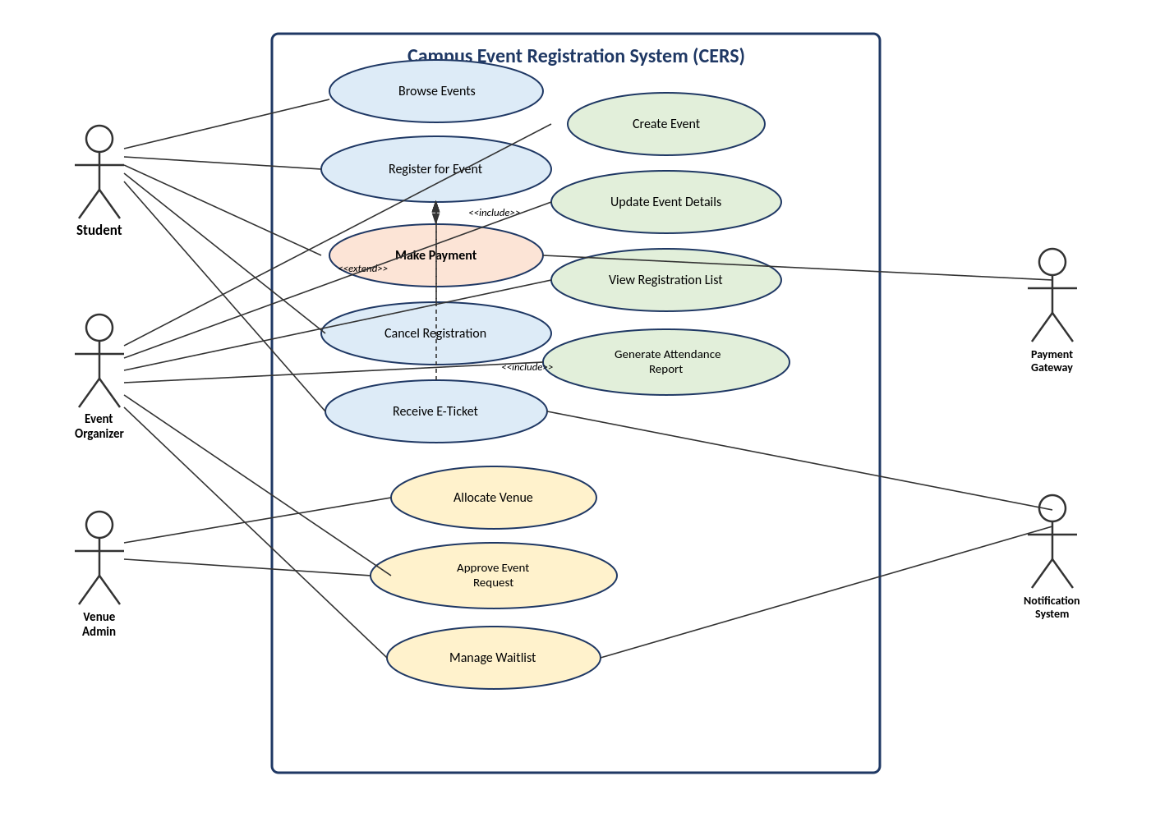
Figure 1: Use Case Diagram for the Campus Event Registration System (CERS)
The diagram shows the CERS system boundary with three primary human actors — Student, Event Organizer, and Venue Administrator — and two external system actors — Payment Gateway and Notification System. Twelve goal-oriented use cases are shown. «include» relationships connect Register for Event to Make Payment and Receive E-Ticket, since both are mandatory sub-steps of a successful registration. An «extend» relationship connects Cancel Registration to Register for Event, since cancellation is an optional flow that only occurs after a registration already exists.

7.3 Detailed Use Case Descriptions
Four use cases were selected for full documentation, including the critical transaction “Make Payment”.

Use Case 1: Register for Event
Use Case Name | Register for Event
Primary Actor | Student
Supporting Actors | Event Organizer (event data), Notification System
Brief Description | Allows a student to reserve a seat at a campus event, subject to availability, as the entry point into the payment and ticketing flow.
Trigger | Student selects “Register” on an event listing.
Preconditions | Student is logged in.  The event is published and open for registration.
Main Success Scenario | 1. Student browses the event list and selects an event.  2. System displays event details and available seats.  3. Student selects “Register”.  4. System validates student eligibility and checks seat availability.  5. System reserves a seat and creates a pending registration record.  6. If the event has a fee, system invokes the Make Payment use case.  7. System confirms registration and triggers Receive E-Ticket.
Alternative/Exception Flows | 3a. Event is at full capacity: system offers to add the student to the waitlist (Manage Waitlist).  4a. Student is not eligible (e.g., already registered): system displays an error and ends the use case.  6a. Payment fails: system keeps the registration pending and prompts the student to retry payment.
Postconditions | A confirmed registration record exists, seat count is decremented, and the student has received an e-ticket.
Assumptions | The student has a valid university account and an active internet connection.
Related Functional Requirements | FR2, FR3, FR4, FR6
Possible Test Cases | TC1: Register for an event with available seats → registration succeeds and e-ticket is issued.  TC2: Attempt to register for a full event → student is placed on the waitlist instead.

Use Case 2: Make Payment
Use Case Name | Make Payment
Primary Actor | Student
Supporting Actors | Payment Gateway (external system)
Brief Description | Processes payment for a paid event as part of completing a registration; this is the critical transaction of the system.
Trigger | Included automatically by Register for Event when the selected event has a fee.
Preconditions | A pending registration exists.  The event fee amount is known.
Main Success Scenario | 1. System presents the payment amount and available payment methods to the student.  2. Student selects a payment method (mobile money or card) and confirms.  3. System sends a payment request to the Payment Gateway.  4. Payment Gateway processes the transaction and returns a confirmation.  5. System records the payment and marks the registration as confirmed.
Alternative/Exception Flows | 4a. Payment Gateway declines the transaction: system notifies the student and allows a retry with a different method.  4b. Payment Gateway times out: system marks the registration as pending and instructs the student to check status later.
Postconditions | Payment record is created and linked to the registration; registration status changes from pending to confirmed.
Assumptions | The student has sufficient funds and a working mobile money or card account.
Related Functional Requirements | FR3, FR4
Possible Test Cases | TC1: Submit payment with sufficient funds → payment succeeds and registration is confirmed.  TC2: Submit payment with an expired card → system displays a decline message and allows retry.

Use Case 3: Create Event
Use Case Name | Create Event
Primary Actor | Event Organizer
Supporting Actors | Venue Administrator
Brief Description | Allows an event organizer to define a new campus event, including requesting a venue, for eventual publication.
Trigger | Organizer selects “Create New Event” from the organizer dashboard.
Preconditions | Organizer is logged in with organizer privileges.
Main Success Scenario | 1. Organizer enters event title, description, date, time, capacity, and fee (if any).  2. Organizer submits a venue request for the event.  3. System forwards the venue request to the Venue Administrator (Allocate Venue).  4. Venue Administrator approves the request.  5. System publishes the event, making it visible to students.
Alternative/Exception Flows | 4a. Venue Administrator rejects the request due to a conflict: system notifies the organizer to select a different date/venue.  1a. Organizer saves the event as a draft without submitting for venue approval.
Postconditions | A new event record exists; if approved, the event is visible to students for registration.
Assumptions | The organizer has authority to plan the event on behalf of their department or group.
Related Functional Requirements | FR7, FR9
Possible Test Cases | TC1: Create an event with an available venue and date → event is published after approval.  TC2: Create an event with a venue already booked for that time → request is rejected with a conflict message.

Use Case 4: Generate Attendance Report
Use Case Name | Generate Attendance Report
Primary Actor | Event Organizer
Supporting Actors | None
Brief Description | Allows an organizer to produce a summary of confirmed registrations and attendance for a given event.
Trigger | Organizer selects “Generate Report” for a specific event.
Preconditions | At least one student has registered for the event.
Main Success Scenario | 1. Organizer selects the event and requests a report.  2. System retrieves confirmed registration records for the event.  3. System compiles totals (registered, waitlisted, cancelled) and a list of attendees.  4. System displays/exports the report to the organizer.
Alternative/Exception Flows | 2a. No registrations exist yet: system displays an empty report with a notice.
Postconditions | An attendance report is generated and available for download.
Assumptions | Registration data for the event is complete and up to date at the time of report generation.
Related Functional Requirements | FR8
Possible Test Cases | TC1: Generate a report for an event with 50 confirmed registrations → report lists all 50 correctly.  TC2: Generate a report for an event with zero registrations → system returns an empty but valid report.

7.4 Use Case-to-Requirement Traceability
Use Case | Related Functional Requirement | Actor(s) | Possible Test Case
Register for Event | FR2, FR3, FR4, FR6 | Student | Register for an available event and confirm e-ticket issuance.
Make Payment | FR3, FR4 | Student, Payment Gateway | Submit payment with insufficient funds and confirm decline handling.
Create Event | FR7, FR9 | Event Organizer, Venue Administrator | Create event with conflicting venue and confirm rejection.
Generate Attendance Report | FR8 | Event Organizer | Generate report for event with mixed confirmed/cancelled registrations.
Cancel Registration | FR5 | Student | Cancel a confirmed registration and confirm seat is released.
Manage Waitlist | FR6, FR10 | Student, Notification System | Add student to waitlist and confirm notification when a seat opens.

7.5 Presentation Questions for Task 1 (Group Notes)
- Most important actors: Student and Event Organizer, since they drive the two core workflows (registration and event creation).
- Most critical use case: Make Payment, because it directly affects whether a registration is confirmed.
- Realistic alternative flow: payment decline handling, which reflects a common real-world mobile money failure.
- Influence of requirements gathering: the questionnaire responses indicating strong preference for mobile money shaped the Make Payment flow.
- Use cases for testing: each fully dressed use case's alternative flows were converted directly into test cases (see traceability table).

8. Task 2: Data Flow Diagram Analysis
This section analyzes the same CERS scenario from the perspective of data movement, focusing on what data enters the system, how it is processed, where it is stored, and what outputs are produced. The diagrams below present a logical DFD, focusing on what the system does rather than the specific technology used to implement it.

8.1 System Boundary and Preliminary Process Analysis
The system boundary encloses all processes involved in event creation, student registration, payment processing, venue allocation, waitlisting, and reporting. Outside the boundary are the Student, Event Organizer, Venue Administrator, and the two external systems: Payment Gateway and Notification System.
External entities: Student, Event Organizer, Venue Administrator, Payment Gateway, Notification System.
Major processes: Manage Event Listings, Register Student for Event, Process Payment, Allocate Venue, Manage Waitlist, Generate Reports and Send Notifications.
Major data stores: Event Records, Registration Records, Payment Records, Venue Records, Waitlist Records, and (at Level 1) Student Records.

8.2 Context Diagram
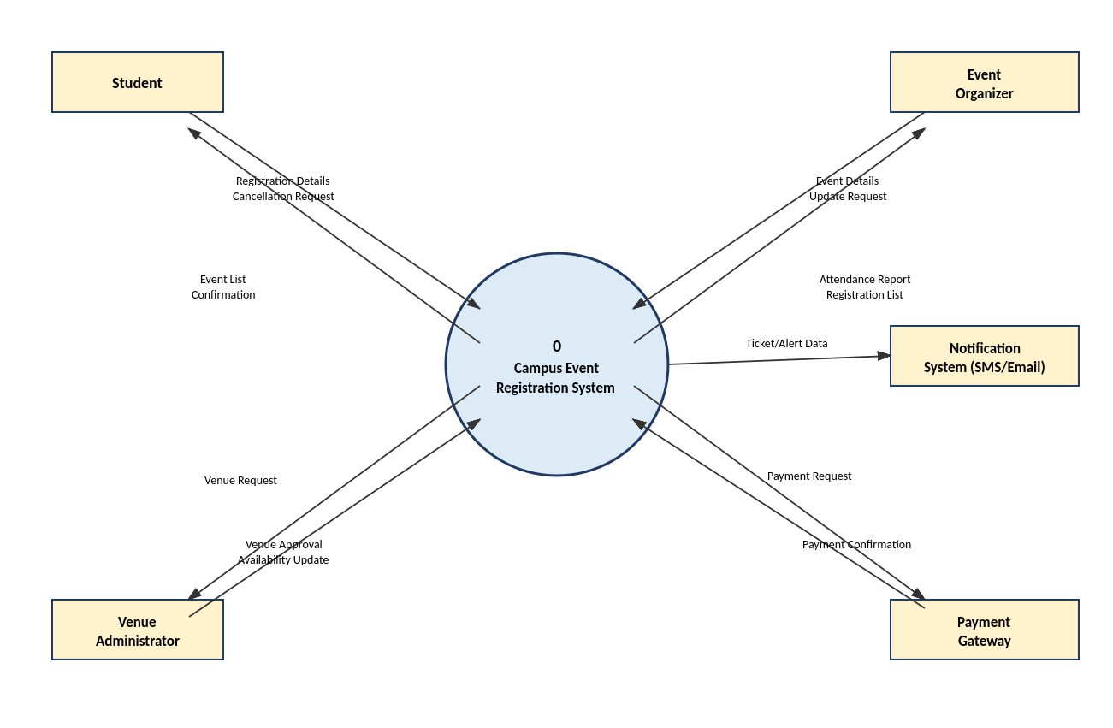
Figure 2: Context Diagram for the Campus Event Registration System (CERS)
The context diagram treats CERS as a single process (Process 0) and shows the five external entities that exchange data with it. Students send registration details and cancellation requests and receive the event list and confirmations. The Event Organizer sends event details and receives attendance reports. The Venue Administrator sends approval decisions and receives venue requests. The Payment Gateway exchanges payment requests and confirmations, and the Notification System receives ticket and alert data for delivery to students.

8.3 Level 0 Data Flow Diagram
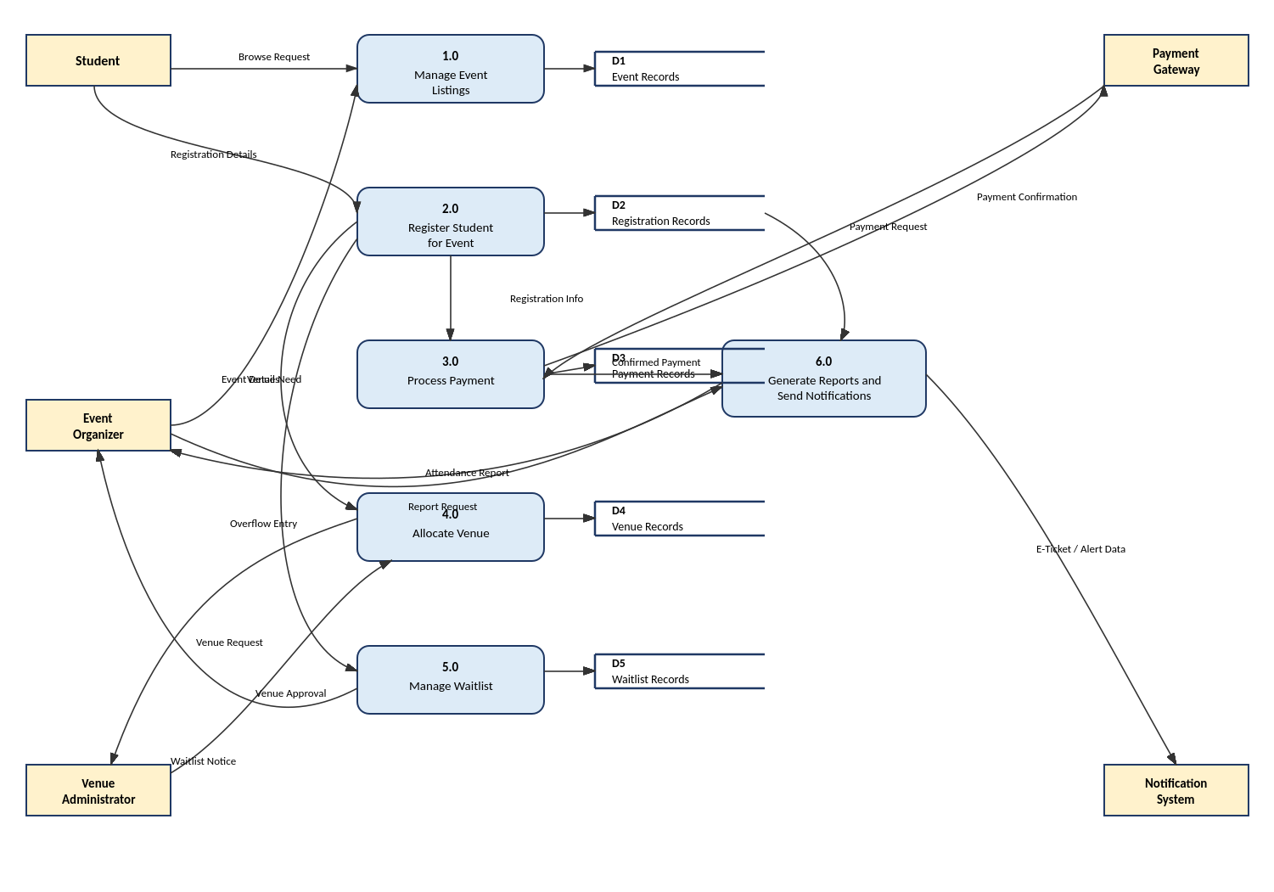
Figure 3: Level 0 DFD — Decomposition of CERS into Major Processes
The Level 0 DFD decomposes CERS into six major processes: 1.0 Manage Event Listings, 2.0 Register Student for Event, 3.0 Process Payment, 4.0 Allocate Venue, 5.0 Manage Waitlist, and 6.0 Generate Reports and Send Notifications. Each process reads from or writes to at least one data store, and every data store is connected to at least one process, consistent with DFD rules. Note that the Student and Event Organizer entities never connect directly to each other or to a data store — all exchanges are routed through a process.

8.4 Level 1 Data Flow Diagram
Process 2.0 (Register Student for Event) was selected for further decomposition because it is the most critical process in the system, coordinating eligibility checking, seat availability, and handoff to payment.
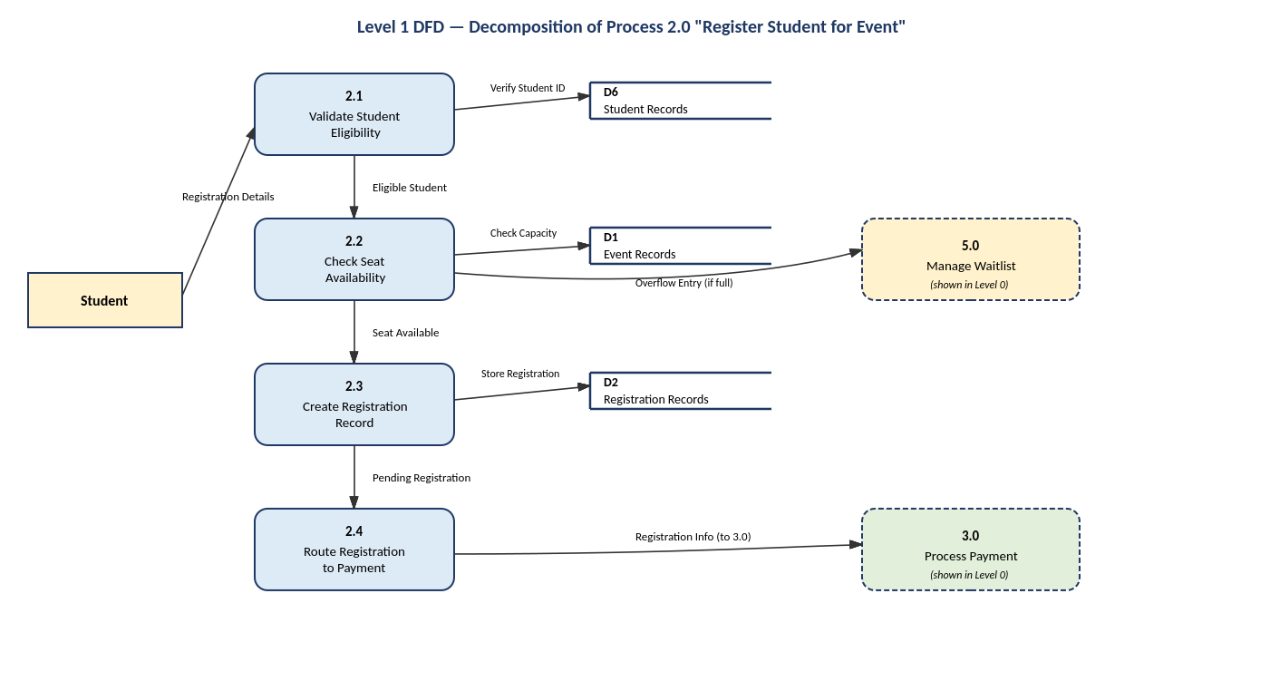
Figure 4: Level 1 DFD — Decomposition of Process 2.0 “Register Student for Event”
Process 2.0 is decomposed into four subprocesses: 2.1 Validate Student Eligibility (checks against Student Records), 2.2 Check Seat Availability (checks against Event Records), 2.3 Create Registration Record (writes to Registration Records), and 2.4 Route Registration to Payment (hands off to Process 3.0). If seats are unavailable, the flow routes to Process 5.0 Manage Waitlist, shown here as an external reference since it is fully detailed at Level 0. The inputs (Registration Details from Student) and outputs (Registration Info to Process 3.0) of this decomposition match the inputs and outputs of Process 2.0 in the Level 0 diagram, satisfying the balancing rule.

8.5 DFD Documentation Tables

External Entity Table
External Entity | Role in the System | Data Sent | Data Received
Student | Initiates registration and payment for events. | Registration Details, Cancellation Request | Event List, Confirmation, Waitlist Notice
Event Organizer | Creates and manages events; requests reports. | Event Details, Report Request | Attendance Report, Registration List
Venue Administrator | Approves or rejects venue requests. | Venue Approval | Venue Request
Payment Gateway | Processes payment transactions externally. | Payment Confirmation | Payment Request
Notification System | Delivers tickets and alerts to students. | (none — receives only) | E-Ticket/Alert Data

Process Description Table
Process No. | Process Name | Input Data | Output Data
1.0 | Manage Event Listings | Event Details, Browse Request | Event List
2.0 | Register Student for Event | Registration Details, Venue Need | Registration Info, Overflow Entry
3.0 | Process Payment | Confirmed Payment (info), Payment Confirmation | Payment Request, Confirmed Payment
4.0 | Allocate Venue | Venue Request | Venue Approval, Venue Request (to Admin)
5.0 | Manage Waitlist | Overflow Entry | Waitlist Notice
6.0 | Generate Reports and Send Notifications | Confirmed Payment, Report Request | Attendance Report, E-Ticket/Alert Data

Data Store Table
Data Store ID | Data Store Name | Data Stored | Processes Using It
D1 | Event Records | Event title, date, time, venue, capacity, fee | 1.0, 2.0, 2.2 (Level 1)
D2 | Registration Records | Student ID, event ID, status (pending/confirmed/cancelled) | 2.0, 6.0, 2.3 (Level 1)
D3 | Payment Records | Transaction ID, amount, status, timestamp | 3.0
D4 | Venue Records | Venue name, capacity, booking schedule | 4.0
D5 | Waitlist Records | Student ID, event ID, waitlist position | 5.0
D6 | Student Records | Student ID, name, programme, eligibility status | 2.1 (Level 1)

Data Flow Table
Data Flow Name | Source | Destination | Description
Registration Details | Student | 2.0 Register Student for Event | Student's chosen event and personal identifiers.
Payment Request | 3.0 Process Payment | Payment Gateway | Amount and payment method sent for processing.
Payment Confirmation | Payment Gateway | 3.0 Process Payment | Result of the transaction (approved/declined).
Venue Request | 4.0 Allocate Venue | Venue Administrator | Details of the venue and time slot requested by an organizer.
Venue Approval | Venue Administrator | 4.0 Allocate Venue | Decision on whether the venue request is granted.
Overflow Entry | 2.0 Register Student for Event | 5.0 Manage Waitlist | A registration attempt made after the event reached capacity.
Attendance Report | 6.0 Generate Reports and Send Notifications | Event Organizer | Summary of confirmed, waitlisted, and cancelled registrations.

8.6 Presentation Questions for Task 2 (Group Notes)
- Main external entities: Student, Event Organizer, Venue Administrator, Payment Gateway, Notification System.
- Most important process to decompose: Process 2.0, because it coordinates eligibility, capacity, and payment handoff — the heart of the registration workflow.
- Most important data stores: Registration Records and Payment Records, since they directly determine confirmed attendance and revenue reconciliation.
- Most difficult DFD rule to apply: ensuring External Entities never connect directly to Data Stores, which required routing every venue and payment exchange through a process.
- Revealed inefficiency: the As-Is process has no equivalent of Process 5.0 (Manage Waitlist), which explains why overcrowding currently occurs.

9. Comparison: Use Case Analysis vs DFD Analysis
Although Task 1 and Task 2 use different modelling tools, both describe the same proposed CERS and reinforce one another:
Use Case | Corresponding DFD Process(es) | Notes
Register for Event | 2.0 Register Student for Event (2.1–2.4 at Level 1) | The use case's main success scenario maps directly onto the Level 1 subprocesses.
Make Payment | 3.0 Process Payment | The «include» relationship in the use case diagram mirrors the direct process link from 2.0 to 3.0 in the DFD.
Create Event | 1.0 Manage Event Listings, 4.0 Allocate Venue | Creating an event triggers both a listing update and a venue approval process.
Generate Attendance Report | 6.0 Generate Reports and Send Notifications | The organizer's reporting goal is fulfilled by this process reading Registration Records.
Manage Waitlist | 5.0 Manage Waitlist | Directly corresponds; both models treat waitlisting as a distinct flow triggered by capacity limits.
The Student actor in the use case diagram appears as the Student external entity in the DFD, since the student both sends data (registration details) and receives data (e-tickets) across the system boundary. Likewise, functional requirement FR6 (waitlisting) is reflected both in the Manage Waitlist use case and in Process 5.0 and Data Store D5 in the DFD, and Registration Records (D2) supports both the Register for Event and Cancel Registration use cases.

10. Conclusion and Lessons Learned
This project demonstrated how Use Case Analysis and Data Flow Diagram Analysis, though built on different notations, describe a single coherent system from complementary angles: actor goals and functional behaviour on one hand, and data movement and storage on the other. Working through the As-Is problems of the manual event registration process at USTED helped the group appreciate why structured requirements gathering and feasibility analysis must precede diagramming.
Key lessons learned include the importance of keeping actors, use cases, processes, and data stores consistent across both models; the discipline required to satisfy DFD balancing rules between Level 0 and Level 1; and the value of tracing every use case back to a specific functional requirement and test case, which made the analysis verifiable rather than purely illustrative.

11. Appendices

Appendix A: Sample Interview Questions (Hypothetical)
- How do you currently announce and collect registrations for your events?
- What challenges have you faced with venue booking or overcrowding?
- How do you currently collect and reconcile payments for paid events?

Appendix B: Sample Questionnaire Items (Hypothetical)
- Would you prefer to register for campus events online rather than on paper? (Yes/No)
- Which payment method would you most likely use for a paid campus event? (Mobile Money / Card / Cash)
- How do you currently find out about upcoming campus events?

